**WeatherPy Analysis**

This analysis used a random sampling of cities within 90 degrees latitude north and south of the equator.

Temperature

Using the sampling the temperature rises as cities become closer to the equator, and falls as they move away as seen below.

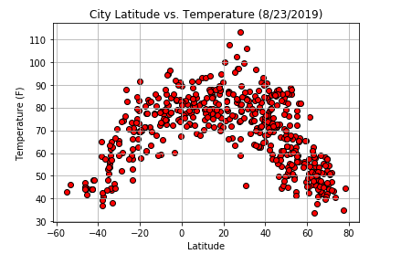

Cloudiness and Wind Speed

Cloudiness and Wind Speed are not seemingly connected to the latitude of cities and does not show an observable trend.

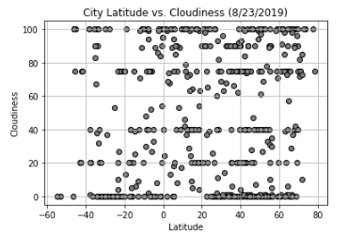 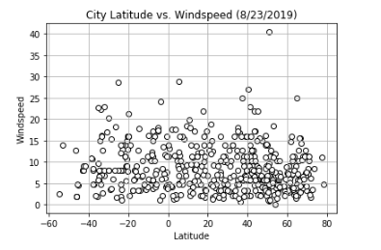

Populated Centers

As seen above more cities are present above the equator than below, which might be due to more land mass above the equator than below.